Discussion form unit 1
Half adder would be a suitable combinational logic circuit that performs the addition operation (A + B) and produces the 2-bit result C. According to Geeks For Geeks (2023), half adder refers to a combinational arithmetic circuit that adds two numbers produces a sum bit (s), and carries bit (c) both as output. The SUM output is the least significant bit (LSB) of the result, which is the XOR of the two inputs A and B. The XOR gate implements the addition operation for binary digits, where a “1” is generated in the SUM output only when one of the inputs is “1” (Geeks For Geeks, 2023). On the other hand, The CARRY output is the most significant bit (MSB) of the result, indicating whether there was a carry-over from the addition of the two inputs. The CARRY output is the AND of the two inputs A and B. The AND gate generates a “1” in the CARRY output only when both inputs are “1” (Geeks For Geeks, 2023). Generally, the input variables are augend and addend bits, while the output variables are sum and carry bits. By considering two input bits A and B, the sum bit (s) is the X-OR of A and B. It is evident from the function of a half adder that it requires one X-OR gate and one AND gate for its construction. Below is the truth table.
A | B | SUM | CARRY
0 | 0 | 0 | 0
0 | 1 | 1 | 0
1 | 0 | 1 | 0
1 | 1 | 1 | 1

Using K-Map to perform addition (A⊕B)
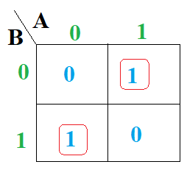
Using K-Map to perform carry (A*B)
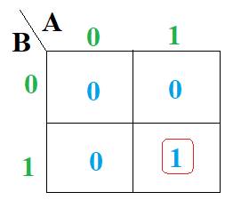
Logic gate implementation
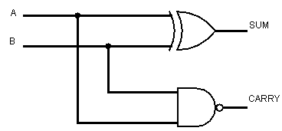
Analysis of Circuit Behavior
- When both inputs are 0, the sum = 0, and the carry = 0.
- When one input is 1 and the other is 0, the sum = 1, while the carry = 0.
- When both inputs are 1, the sum is 0, while the carry is 1 (1 + 1 = 10 in binary).
In a nutshell, the half adder produces a circuit that ensures all combinations of inputs produce the correct 2-bit binary sum.
Reference
Geeks For Geeks. (2023, May 6). Half Adder in Digital Logic. GeeksForGeeks. https://my.uopeople.edu/mod/forum/view.php?id=423222

